**VMM UBUNTU IMAGE SETUP**

1. Open VMM application go to the desktop icon on the top-left corner

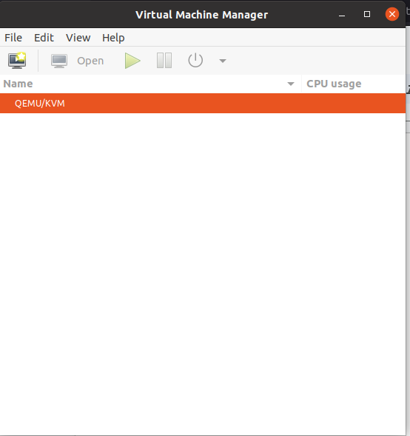

2.click forward

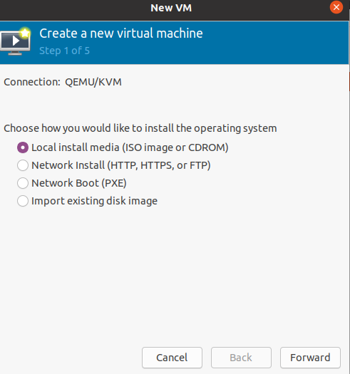

3.browse and select the iso image file from the system and click forward

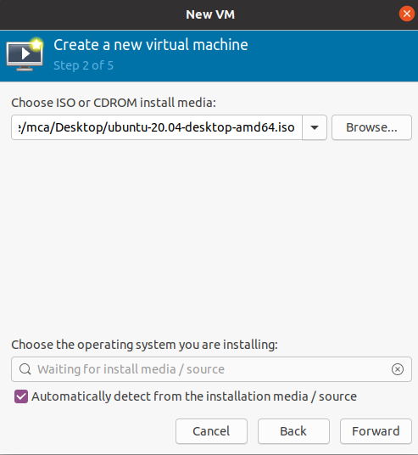

4.setup memory ,click forward

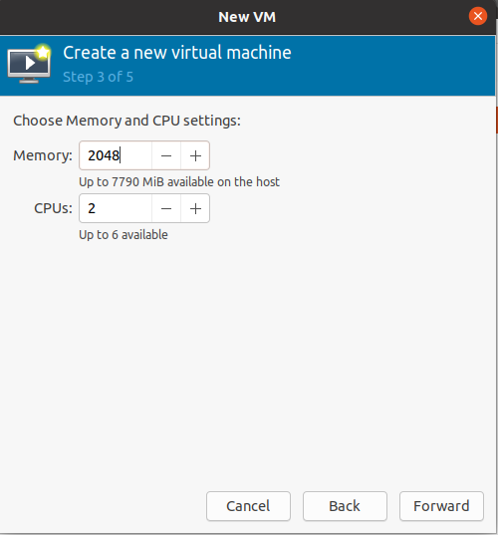

5.click forward

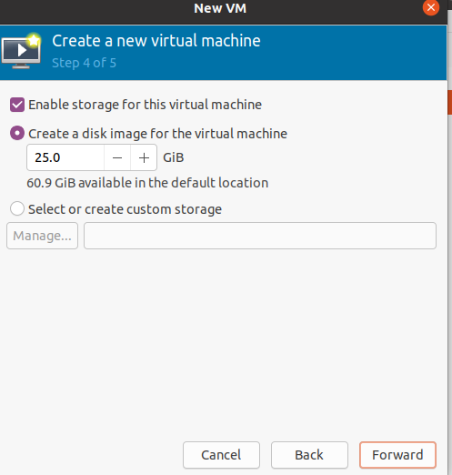

6. Give the virtual machine a name. Then click finish

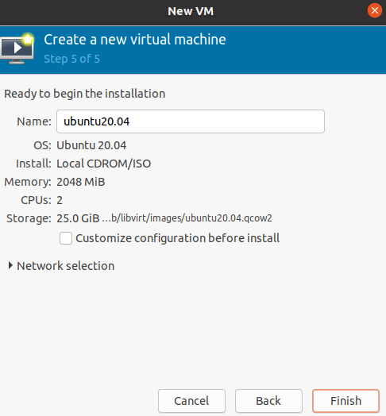

7.Now our VM is ready to run

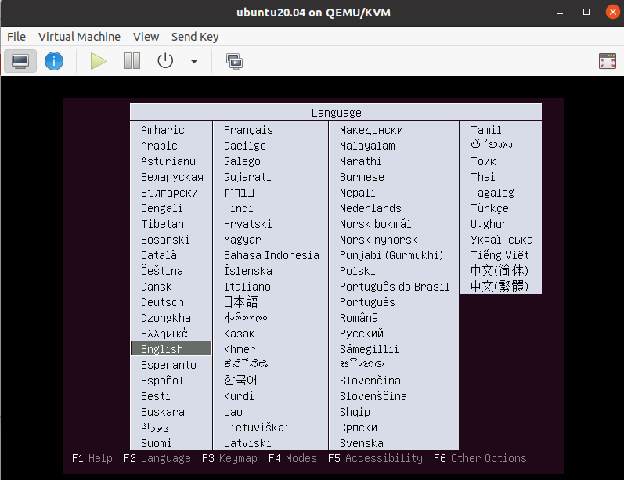

8.Running status of VM

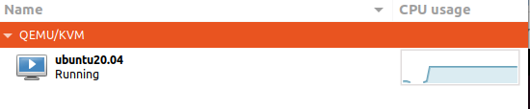

9.Shutdown the VM

